7.5 - Effects of the Second World War on the Pacific

Democratization of Japan and US Occupation
  - Japan was defeated mostly by the U.S
    - Occupation fell into hands of U.S. and appointed supreme allied commander of General MacArthur
  - US goals for Japan:
    - Develop liberal democracy
    - Develop free market economy
  - Occupation terms
    - War crime punishments
    - Disband military+disarmament
    - Former military leaders cannot hold office
    - Disband large corporations like “zaibatsu”
    - Emperor must renounce “divinity” -> figurehead replacement role
    - Land break-ups to favor small holds
    - US military bases remained in Okinawa+Japan
- US provided Japan with Aid (1945-1950)
    - During Korean War Japan’s location provided it as an economic hotspot
      - US occupation ends in Japan in 1952
      - However, Peace did not occur
        - Continued demilitarized parliamentary with market economy

Imperialism and Decolonization
  - Shift in the global power of Britain and France as hegemons in their regions
  - Existence of “global empires” post 1945 shifts
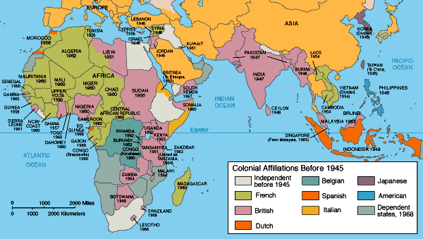
Map showing the colonial holdings of global powers before 1945

  - WWII battles conveyed the difficulty of defending the geographically scattered colonies
  - 1945 - Clement Attlee’s Labor Government leads to contemplation and conversation regarding the political independence of British colonies such as India
  - Different situation regarding French colonies in Asia following the detonation of the atomic bomb in Japan
    - Active Japanese troops were forced to demobilize haphazardly
    - Massive Japanese casualties -> Samurai + Bushido code, no surrender
  - Unlike Britain, the French government assumed that French control of Indo-China would resume as normal following the end of World War II
    - Growing tensions as Ho Chi Minh in Vietnam begins to grow the country towards Northern Indo-China
    - Leads to 9 years of warfare between Viet Minh & French forces
Cold War
- US solely occupies power in Japan
  - Rehabilitation and political direction of Japan determined by US
- Japanese imperial holdings split amongst Allied Powers
- Countries in control:
  - China controls Taiwan
  - USSR controls north side of Korea
  - US controls south side of Korea
  - Britain controls Hong Kong
- USSR honors pledge to declare war on Japan
- USSR invades Mongolia (August 1945)
  - Day after bombing Hiroshima
    - Decided to bomb in order for US to accept USSR help in defeating Japan
- Atomic bomb lead to US not needing help from Allied Powers
  - Britain, China, France did not focus on Japan
- Occupation of Japan important to US
  - To serve as critical base for US and United Nations during Korean War
Timeline:

- USSR invades Mongolia (August 1945)
- Truman's growing disgust of stalins and his policies
- 1945 - Clement Attlee’s Labor Government leads to contemplation and conversation regarding the political independence of British colonies such as India
- US provided Japan with Aid (1945-1950)
- In 1952 the us occupation of japan formally ended (although the peace with japan didn't)

