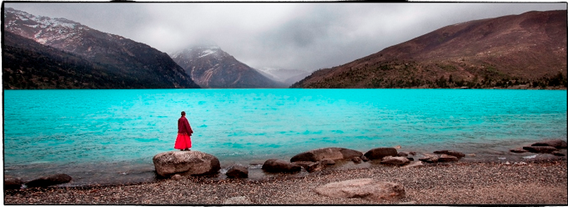
Phil Borges
Mercer Island, WA
Social Documentary Photographer and filmmaker

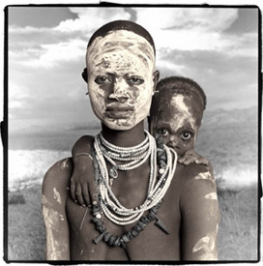
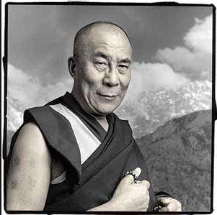
About the artist: Phil Borges documents indigenous and tribal cultures to promote understanding of their challenges. He has published four award winning photography books that highlight the cultures of Tibet and other indigenous groups. With work exhibited world wide, Phil Borges lectures and teaches internationally, and has worked with Discovery and National Geographic hosting television documentaries on indigenous cultures. He has photographed the Dalai Lama and has a recent project challenging the mental health crisis.
