Name:
Read instruction sheet posted under the materials tab “Northern Renaissance Wrap-up”
Step 1:

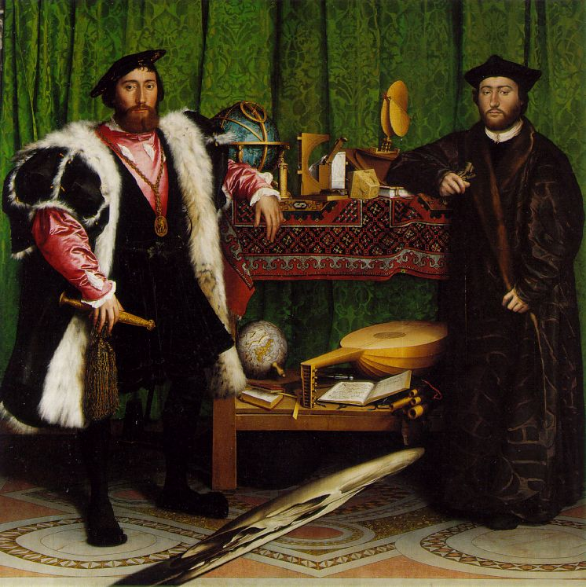

Step 2:

Step 3:

Step 4:

Step 5:

